

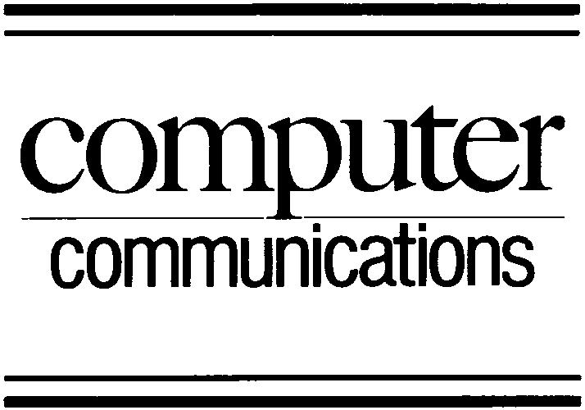

Computer Communications 27 (2004) 1684–1692

www.elsevier.com/locate/comcom

Abstract

Review of quality of service performance in wireless LANs
and 3G multimedia application services

Nilufar Baghaei, Ray Hunt*

Department of Computer Science, University of Canterbury, Private Bag, Christchurch 4800, New Zealand
Received 25 May 2004; accepted 25 May 2004
Available online 31 July 2004

Although, many architectures (Integrated Services, Differentiated Services, MPLS, Trafﬁc Engineering, etc.) have been proposed to
provide service differentiation in ﬁxed networks, research has shown that what works well in a wired network cannot be directly applied in
the wireless environment where bandwidth is scarce and channel conditions are time varying. Quality of Service (QoS) is a key challenge for
today’s wireless IP networks and implementation of QoS, particularly for supporting voice, video, data and multimedia services in general
incurs a number of difﬁculties that have to be analysed and resolved. A considerable amount of work has been carried out by the various
standards groups in an effort to quantify and specify protocols to support QoS in wireless environments. This paper reports on these efforts
outlining existing limitations, requirements and solutions proposed by organisations such as the IEEE 802.11 Task Group E for wireless
LANs and the UMTS effort for 3G/wireless WANs.
q 2004 Elsevier B.V. All rights reserved.
Keywords: Quality of Service; IEEE 802.11a/b/g WLANs; 3G/UMTS/cdma2000 Networks; Multimedia over wireless networks

1. Introduction

Most current network architectures treat all packets in the
same way—a single level of service. Applications, however,
have diverse requirements and may be sensitive to latency
and packet losses. Examples include interactive and
real-time applications such as IP telephony; streaming
services such as audio, video and bulk data streaming;
and interactive services such as voice, web and transaction
service processing. When the latency or the loss rate
exceeds certain levels, these applications become unusable.
In contrast, both reliable (tcp) and unreliable (udp) services
can tolerate signiﬁcant delay and loss without much
degradation of perceived performance.
The capability to provide resource assurance in a
network is often referred to as Quality of Service (QoS)
which is critical requirement in order that new IP-based
applications can operate within well-deﬁned parameters.
Resource assurance can currently be provided in a
multiservice network by the use of IP service differentation
(DiffServ), although resource assurance can only truly be

* Corresponding author. Tel.: ю 64-3-3642347; fax: ю64-3-3642569.
E-mail address: ray@cosc.canterbury.ac.nz (R. Hunt).
0140-3664/$ - see front matter q 2004 Elsevier B.V. All rights reserved.
doi:10.1016/j.comcom.2004.05.019

guaranteed by the use of the Integrated Services (IntServ)
model. Implementing these QoS capabilities has become
one of the most difﬁcult challenges, particularly as this often
requires changes to its basic network architecture.
The requirements for each type of trafﬁc ﬂow can be
characterised by four primary parameters: reliability,
delay, jitter, and bandwidth. Several common applications
are listed in Table 1 along with the stringency of their
requirements. Table 2 (adopted from Ref. [1]) shows a
similar set of requirements for applications operating in
a wireless WAN (3G) environment.
Most IP-based networks rely on the TCP protocol to
detect congestion in the network and to reduce the
transmission rates accordingly. TCP-based resource
allocation requires all applications to use the same
congestion control scheme. Although such co-operation is
achievable within a small group, in a network as large as the
Internet, it can be easily abused. Furthermore, many
UDP-based applications do not support TCP-like
congestion control, and real-time applications typically
cannot cope with large ﬂuctuations in the transmission rate.
The service currently provided by default is often
referred to as best effort. When a link is congested,
packets are simply discarded as the queue overﬂows.

N. Baghaei, R. Hunt / Computer Communications 27 (2004) 1684–1692

1685

Table 1
Common wired-network performance characteristics

have been proposed and experimented with to date. Finally,
it discusses the new IEEE 802.11e QoS enhancements.

Application

E-mail
Reliability Delay

High Low
Jitter

Low
Bandwidth

Low

2.1. An Overview of IEEE 802.11 MAC Operation

File transfer
High
Low
Low
Medium
In general, the IEEE 802.11 WLAN standard covers the

Web access
High
Medium Low
Medium
MAC sub-layer and the physical layer of the OSI network

Remote login
High
Medium Medium Low
reference model. The Logical Link Control (LLC) sub-layer

Audio on demand Low
Video on demand Low
Low
Low
High
High
Medium
High
is speciﬁed in the IEEE 802.2 standard. This architecture

Telephony
Low
High
High
Low
provides a transparent interface to higher layer users:

Videoconferencing Low
High
High
High
stations may move, roam through an IEEE 802.11 WLAN
and still appear as stationary to the IEEE 802.2 LLC
sub-layer and above. This allows existing network protocols

Since, the network treats all packets equally, any ﬂows
could be hit by congestion and this particularly impinges on
wireless and mobile connections, commonly as a result of
limited bandwidth. Although best-effort service is
adequate for some applications that can tolerate large
delay variation and packet losses, it clearly does not satisfy
the needs of many new time-sensitive multimedia-based
applications.
Resource assurance is critical for many new wireless
applications. Although, the Integrated Services (IntServ)
and Differentiated Services (DiffServ) paradigms ﬁgure
predominantly as QoS solutions, they focus on the IP layer
and it is necessary for the underlying layers to be able
to respond to and conﬁgure such IP-based service
requirements. The following sections address
the speciﬁcation and provisioning of these underlying
QoS-based requirements for both wireless LAN and
wireless WAN (3G) architectures.

2. QoS in IEEE 802.11 Wireless LANs

In its current form, the IEEE 802.11 wireless LAN
standard [2] cannot provide QoS support for the increasing
number of applications which demand QoS parameters—
typical of many multimedia applications. A number of IEEE
802.11 QoS enhancement schemes have been proposed, each
focusing on a particular mode of operation. This section ﬁrst
analyses the QoS limitations of the IEEE 802.11 MAC layer
and then summarises the QoS enhancement schemes that

Table 2
Common wireless WAN (3G) network performance characteristics
Application Reliability Delay Jitter Bandwidth
(such as TCP/IP) to transparently operate over IEEE 802.11
WLANs without any special considerations.
At the PHY layer, the IEEE 802.11 standard provides
three alternatives for operation in the 2.4 GHz band:

† Infrared (IR) base-band PHY
† Frequency Hopping Spread Spectrum (FHSS) radio
† Direct Sequence Spread Spectrum (DSSS) radio.

All three PHY layers support both 1 and 2 Mbps
operation. In 1999, the IEEE deﬁned an 11 Mbps 802.11b
standard designed to operate in the 2.4 GHz free ISM
(Industrial, Science, and Medical) band and a 54 Mbps
802.11a OFDM (Orthogonal Frequency Division
Multiplexing) standard for operation in the 5 GHz frequency
band.
The IEEE 802.11 MAC sub-layer deﬁnes two related
medium access coordination functions, the Distributed
Coordination Function (DCF) and the optional Point
Coordination Function (PCF) (Fig. 1, adopted from Ref. [3]).
The IEEE 802.11 MAC protocol supports two types of
transmission: Asynchronous and Synchronous [2].
Asynchronous transmission is provided by the DCF, which
implements the basic access method for the IEEE 802.11
MAC protocol. DCF is based on the Carrier Sense Multiple
Access with Collision Avoidance (CSMA/CA) protocol,
and is the default implementation. The Synchronous service
(also called contention free service) is provided by PCF and
implements a polling-based access method. The PCF uses a
centralised polling approach that requires an Access Point
(AP) to act as a Point Coordinator (PC). The AP cyclically
polls stations to give them the opportunity to transmit
packets. Unlike the DCF, the implementation of the PCF is
not mandatory. Furthermore, the PCF itself relies on the
underlying asynchronous service provided by the DCF.
Although providing different service functions, neither
DCF nor PCF ю DCF have the ability to offer true QoS to

E-mail
Low
High
–
Low
Wireless LAN applications.

File transfer Low – medium High
–
High

Web access Low – medium Medium –
Medium
2.2. QoS limitations of IEEE 802.11 MAC

Remote login Low
Control Null
Low
Low
–
–
Low
–

In addition to providing channel access (via DCF or

Real time
Low – medium Low
Low Medium – high
PCF ю DCF), the wireless LAN MAC layer needs to

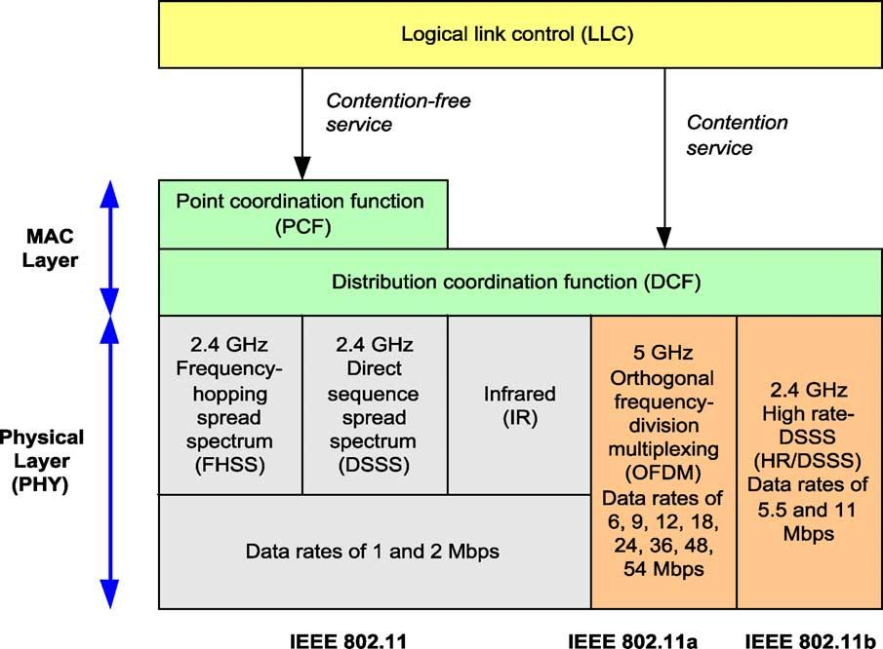

1686

provide facilities for:

† maintaining QoS
† providing security.

N. Baghaei, R. Hunt / Computer Communications 27 (2004) 1684–1692

Fig. 1. PCF and DCF in IEEE 802.11 MAC layer.

services such as Voice over IP, audio and videoconferencing
require speciﬁed bandwidth, delay and jitter, but can also
tolerate some loss. However, in DCF mode, all the stations
in one BSS or all the ﬂows in one station compete for the
resources and channel with the same priority. There is no

Wireless links have speciﬁc characteristics such as
reliability, bandwidth, packet delay and jitter. Furthermore,
the wireless link characteristics are not constant and may
vary over time and place. Mobility of users may cause the
end-to-end path to change when users roam, and further,
users will expect to receive the same QoS as they change
from one Access Point (AP) to another. This implies that the
new path should also support the existing QoS by service
reservation, and problems may arise when the new path
cannot support such requirements.
There are two ways to characterise QoS in WLANs, viz.:
parameterised or prioritised QoS [4,5]. Parameterised QoS is
a strict QoS requirement, which is expressed in terms of
quantitative values, such as data rate, delay bound, and jitter
bound. In a Trafﬁc Speciﬁcation (TSpec)—such as is used in
the IntServ model, these values are expected to be met by the
MAC data service in support of the transfer of data frames
between peer stations. In a prioritised QoS scheme, the values
of QoS parameters such as data rate, delay bound, and jitter
bound—typically resulting from a DiffServ model, may vary
during the transfer of data frames. In this instance, there is no
need to reserve the required resources by negotiating the
TSpec between the station and the AP as the DiffServ queue
architecture is relied upon to manage the QoS.

2.2.1. QoS limitations of DCF
DCF can only support best-effort services and does not
provide any QoS guarantees. Typically, time-bounded
differentiation mechanism to guarantee bandwidth, packet
delay and jitter for high-priority stations or multimedia
ﬂows [6].

2.2.2. QoS limitations of PCF
Although PCF has been designed by the IEEE Working
Group to support time-bounded multimedia applications,
this mode has some major problems, which leads to poor
QoS performance. In particular, the central polling scheme
is inefﬁcient and complex and causes deterioration of the
performance of PCF high-priority trafﬁc under load.
Additionally, all communications have to pass through the
AP which degrades the bandwidth performance [7].

2.3. QoS enhancement schemes for IEEE 802.11 MAC

QoS issues in wired Ethernet have been neglected due to
the relative ease with which the physical layer bandwidth
has improved Normally, the IP layer assumes that a LAN
scarcely drops or delays packets. However, in WLANs,
the challenges of the wireless channel make physical layer
data rate improvements more difﬁcult to achieve,
particularly as the IEEE 802.11 WLAN was originally
designed for best-effort services. The physical layer’s error
rate can be more than three orders of magnitude larger than
that of wired LAN. Further, high collision rate and frequent
retransmissions cause unpredictable delay and jitter,
which further degrade the quality of real-time voice

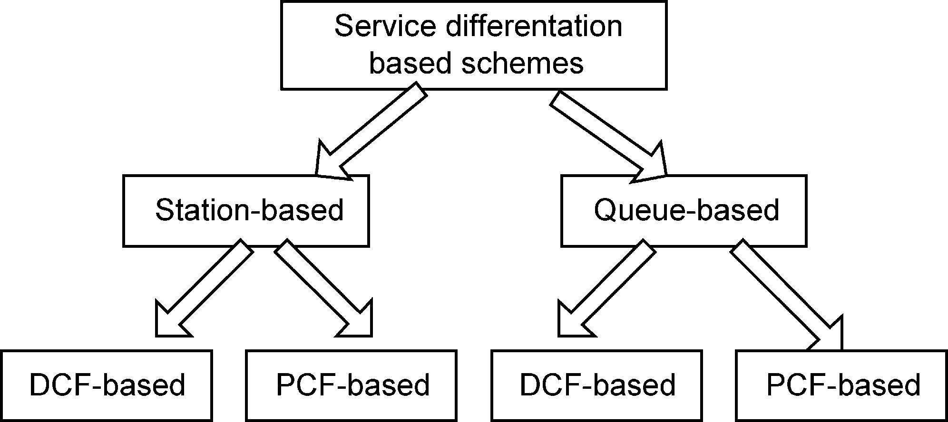

N. Baghaei, R. Hunt / Computer Communications 27 (2004) 1684–1692

1687

and video transmission. To address these issues, a number of
proposals have been made which are detailed in the
following sections.

2.3.1. Service differentiation based enhancement schemes
QoS enhancement can be supported by adding service
differentiation into the MAC layer This can be achieved by
modifying the parameters that deﬁne how a station or a ﬂow
should access the wireless medium. Current service
differentiation-based schemes can be classiﬁed with respect
to a multitude of characteristics. For example, a possible
classiﬁcation criterion can be based upon whether the
schemes base the differentiation on per-station or per-queue
(per-priority) parameters. Another classiﬁcation depends on
whether they are DCF (distributed control) or DCF ю PCF
(centralised control) enhancements. Fig. 2 shows this
classiﬁcation. Previous research work has mainly focused
on the station-based DCF enhancement schemes [6,8,9],
while other recent work has focused on queue-based hybrid
coordination (combined PCF and DCF) enhancement
schemes [10 – 12], since queue-based schemes perform
more efﬁciently.

2.3.2. Error control based enhancement schemes
In parallel, QoS enhancement can also be obtained by
error control mechanisms Since, the network may
occasionally drop, corrupt, duplicate or reorder packets,
the transport protocol (e.g. TCP) or the application itself
(e.g. if UDP is being used) must recover from these errors on
an end-to-end basis. Error recovery in the sub-network is
justiﬁed only to the extent that it can enhance overall
performance. However, some sub-networks such as wireless
links require link layer error recovery mechanisms to
enhance the performance, but these enhancements need to be
lightweight [4]. For example, wireless links normally
require link-layer error recovery (such as IEEE 802.2
LLC) and MAC-level error recovery in the sub-network.

2.3.3. IEEE 802.11e QoS enhancement standards
The focus of the IEEE 802.11 Task Group e (802.11e) is
to enhance the IEEE 802.11 MAC (DCF, PCF) to support
QoS, providing classes of service, enhanced security and
authentication mechanisms. It aims to enhance the ability of
all the physical layers (IEEE 802.11b, 802.11a, 802.11g) to

Fig. 2. Classiﬁcation of service differentiation based schemes.

deliver time-critical multimedia data, in addition to a best
effort data service. There are many new features in the IEEE
802.11e draft 3.0 [13] which enhance the existing DCF and
PCF ю DCF functionality in order to support new QoS
applications [4] and the most important of these are brieﬂy
described.

† EDCF (Enhanced Distribution Coordination Function)
† HCF (Hybrid Coordination Function)
† Direct communication in infrastructure mode
† AP mobility
† MAC-level FEC (Forward Error Correction).

2.3.3.1. Enhanced distribution coordination function
(EDCF) and hybrid coordination function (HCF).
Since, DCF and PCF do not differentiate between trafﬁc
types or sources, the IEEE 802.11 Task Group e is
proposing QoS enhancements via two alternative modes
of operation These changes would let critical service
requirements be fulﬁlled while maintaining backward-
compatibility with current IEEE 802.11 standards.
The proposed enhancement to DCF—Enhanced
Distribution Coordination Function (EDCF)—introduces
the concept of trafﬁc categories. Each station has eight
trafﬁc categories, or priority levels. Using EDCF, stations
try to send data after detecting that the medium is idle and
after waiting a period deﬁned by the corresponding trafﬁc
category called the Arbitration Interframe Space (AIFS).
A higher-priority trafﬁc category will have a shorter AIFS
than a lower-priority trafﬁc category.
To avoid collisions within a trafﬁc category, the station
counts down an additional random number of time slots,
known as a contention window, before attempting to
transmit data. If another station transmits before the
countdown has ended, the station waits for the next idle
period, after which, it continues the countdown where it left
off. No guarantees of service are provided, but EDCF
establishes a probabilistic priority mechanism to allocate
bandwidth based on trafﬁc categories.
Another way IEEE 802.11e aims to extend the polling
mechanism of PCF is with the Hybrid Coordination
Function (HCF). A hybrid controller polls stations during
a contention-free period. The polling grants a station a
speciﬁc start time and a maximum transmit duration. EDCF
appears to be gaining more acceptance than HCF [13,14]. In
addition to the IEEE 802.11e standard, a group of vendors
have proposed Wireless Multimedia Enhancements
(WME), to provide an interim QoS solution for IEEE
802.11 networks.¹

2.3.3.2. Additional IEEE 802.11e daft 3.0 features. IEEE
802.11e adds a capability for stations to send trafﬁc directly

1 For more information, refer to http://grouper.ieee.org/groups/802/11/
Documents/D2T551-600.html.

1688

N. Baghaei, R. Hunt / Computer Communications 27 (2004) 1684–1692

to each other in the infrastructure mode, which signiﬁcantly
improves the bandwidth in certain networks.²
In IEEE 802.11e, AP mobility [13] is introduced by a
concept of QAP-Capable and such a station can operate
either as a real QoS AP (QAP) or a wireless station (WSTA).

Table 3
Typical QoS application requirements in 3G
Type of application and example

(Kbps) Losses
(%)

Delay
(ms)

Therefore, in the IEEE 802.11e draft 3.0 [13], AP mobility
implies the transfer of the AP functionality between different
Data
FTP
Limitless 0
TCP
timer

QAP-Capable stations, i.e. a station can become an AP and
Real time
Audio Voice
#64
10²4#300

Voice over IP 10 – 64 5 – 10²2#300

subsequently change back to a station again.

3. QoS in 3G Wireless Networks

2G networks such as Global System for Mobile
Video MPEG-4
H.320
Non-real time Audio CD

Video MPEG-4
#2000 10²2#40
#64 10²4#40
150 10²4 Buffer
length
Limitless 0 Buffer
length

communications (GSM)/code-division multiple access
(CDMA), have essentially only one QoS option—i.e. speech
at full-rate coding in GSM. Subsequently, a half-rate service
Network
services
Limitless 0
–

was introduced, thus offering a new QoS. In reality,
however, this was done to save network capacity and
therefore serving more users in congested hot spots, rather
than offering a new grade of service to users. The user was not
offered the choice of full/half rate, but, more often, those with
half-rate capable mobile phones were put onto half rate,
without the subscriber knowing that the speech quality has
been deliberately lowered by the network being used.
In 2.5G networks such as general packet radio service
(GPRS), there has been a deliberate attempt to introduce
mechanisms whereby the subscriber can request a different
QoS (average/peak data throughput, packet delay, etc.).
In principle, this QoS requirement can be established at the
beginning of the data transfer session (at Packet Data
Protocol (PDP) context set-up). For example, a user
intending to use an interactive service (such as web surﬁng)
may want to use a service with a faster reaction time/lower
round-trip delay. They can then ask for a smaller packet
delay at PDP context set-up time, and the network can
conﬁrm whether this request is accepted or rejected.
3G is a wireless industry term for a collection of
international standards and technologies aimed at improving
the performance of mobile wireless networks 3G wireless
services offer packet data enhancements to applications and
these include higher speeds, increased capacity for voice
and data services as well as QoS facilities. The two main 3G
technologies for which QoS is being standardised are:

† UMTS (Universal Mobile Telecommunications System)
† cdma2000 (Code Division Multiple Access 2000).³

Table 3 (adopted from Ref. [15]) shows QoS-based
application requirements in terms of bandwidth, delay,
and losses for different categories such as data, real-time

2 This would be the same as ad hoc mode, however in ad hoc mode, there
is no AP deﬁned in the architecture.
3 3GPP is responsible for the UMTS standards speciﬁcation, while
3GPP2 is responsible for the cdma2000 standards speciﬁcation. This has
resulted in two 3G standards being released, i.e. UMTS and cdma2000.
trafﬁc, non-real time trafﬁc, and network services in 3G
networks.

3.1. UMTS/3GPP-deﬁned QoS

3GPP,⁴Third Generation Partnership Project, has
standardised a common QoS framework for IP-based data
services. They have deﬁned a comprehensive framework for
end-to-end QoS covering all subsystems in a UMTS
network, including core network, wireless and universal
terrestrial radio access networks, etc. UMTS is the ﬁrst
wireless data service, which offers a comprehensive QoS
speciﬁcation across a wireless wide area network
infrastructure. In addition, the speciﬁcation provides for
control signaling, user plane transport and QoS management
functionality.
QoS enables a network to deliver classes of service
(CoS), i.e. different prioritised treatments to different
services or to different groups of users. QoS allocates
network capacity according to the type of trafﬁc required
for a certain type of service, while CoS provides
preferred allocation of the network resources in a similar
manner to which DiffServ does for IP-based services.
CoS is implied in a QoS policy associated with a
subscriber. It is used by the network to provide
differential QoS treatments to different services
subscribed by different users.
UMTS deﬁnes QoS classes [16], but cdma2000—at least
in its early formulations—does not. Users of these services
may communicate with both ﬁxed networks and other
mobiles, thus end-to-end performance is also inﬂuenced
by the features of these networks on which other parties may
be situated.
The 3GPP end-to-end QoS speciﬁcation, which includes
the deﬁnition of UMTS QoS architecture, bearer services,
and recommendations for supporting QoS mechanisms, also

4 www.3GPP.org.

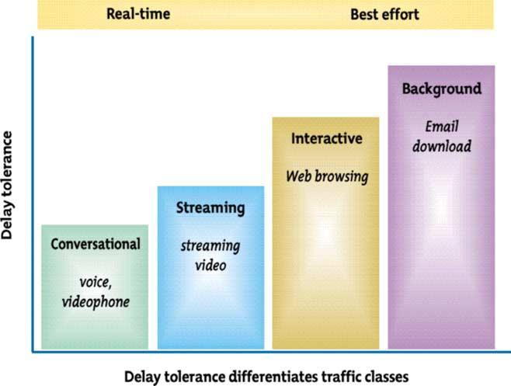

N. Baghaei, R. Hunt / Computer Communications 27 (2004) 1684–1692

1689

Fig. 3. UMTS trafﬁc classes.
establishes four overriding UMTS QoS classes or trafﬁc
classes for wireless data, taking into account the restrictions
and limitations of the air interface. The characteristics of
these four QoS classes are described in the following
sections.

3.1.1. UMTS QoS Basic Classes
The basic classes deﬁned by UMTS/3GPP are [17]:

1. Conversational
2. Streaming
3. Interactive
4. Background.

The main distinguishing factor between these trafﬁc
classes lies with sensitivity to delay (Fig. 3 (adopted from
Ref. [18])).

3.1.1.1. Conversational class. This class applies to any
application that involves real-time person-to-person
communication such as audio voice, videophone etc.
The basic qualities required for speech are low delay,
low jitter, reasonable clarity (common codecs and quality),
and absence of echo. In the case of multimedia applications,

Table 4
End-user performance expectations—conversational/real-time services

such as videoconferencing, it is also necessary to maintain
synchronisation of the different media streams. Failure to
provide low enough transfer delay will result in
unacceptable lack of quality. This class is tolerant of some
errors, e.g. voice packet corruption lasting for up to 20 ms.
However, the degree of error protection required varies with
applications. (Table 4)

3.1.1.2. Streaming class. The streaming class consists of
real-time applications that exchange information between
viewer and listener, without any human response. Examples
of this include video-on-demand, live MPEG4 listening,
Web-radio, news streams, and multicasts. Because of the
absence of interaction, there is no longer a need for low
delay, but the requirements for low jitter and media
synchronisation remain. Error tolerance is a function of
the application. The removal of the low delay criterion
makes it possible to use buffering techniques in the end-user
equipment, so the acceptable level of network jitter is higher
than for the conversational class. (Table 5).

3.1.1.3. Interactive class. This class covers both humans and
machines that interact with another device Examples of this
include some games, network management systems polling
for statistics, and Web-browsing or database retrieval.
Applications in this class are characterised by the request-
response pattern of the end-user. Round-trip delay and
tolerance to packet loss are key QoS characteristics.
(Table 6).

3.1.1.4. Background class. The background class covers all
applications that either receive data passively or actively
request it, but without any immediate need to handle this
data Examples of this include e-mails, short message
service, and ﬁle transfers. The only requirement is for data
integrity, although large ﬁle transfers will also require an
adequate throughput.
Table 7 summarises the characteristics of each of the
above four classes.

Medium Application
Degree of symmetry
Data rate
(Kbps)
Key performance parameters and target values

End-to-end one Delay variation Information loss
way delay within call

Audio

Conversational voice

Two-way

4 – 25

, 150 ms pref.
, 400 ms limit

,1 ms

,3% Frame error rate

Video
Videophone
Two-way
32 – 384 , 150 ms pref.
, 400 ms limit
Lip-sync ,100 ms

,1% Frame error rate

Data
Telemetry—two way control Two-way
,28.8
, 250 ms
NA
Zero

Data
Interactive games
Two-way
,1
, 250 ms
NA
Zero

Data
Telnet
Two-way—asymmetric ,1
, 250 ms
NA
Zero

1690

Table 5

N. Baghaei, R. Hunt / Computer Communications 27 (2004) 1684–1692

End-user performance expectations—streaming services

Medium Application
Degree of Symmetry Data rate (Kbps) Key performance parameters and target values

Audio Speech/music medium/high quality

Primarily one-way 5 – 128

Startup
delay (s)

, 10

Transport delay
variation

,2 s

Packet loss at
session layer

,1% Packet loss ratio

Video Movie clips surveillance real-time video Primarily one-way 20 – 384
, 10
,2 s
,2% Packet loss ratio

Data

Data

Table 6
Bulk data transfer/retrieval, layout,
synchronisation information
Interactive games
Primarily one-way ,384

Primarily one-way
, 10

, 10
NA

NA
Zero

Zero

End-user performance expectations—interactive services

Medium Application
Degree of Symmetry Data rate Key performance parameters and target values
One-way delay Delay variation Information loss

Audio Voice messaging

Primarily one-way 4 – 13 Kbps ,1 s for playback ,1 ms
,2 s for record

,3% Frame error rate

Data
Data

Data
Web-browsing—HTML
Transaction services—high priority,
e.g. ATM
E-mail (server access)
Primarily one-way
Two-way

Primarily one-way
,4 s/page
,4 s

,4 s
NA
NA

NA
Zero
Zero

Zero

3.1.2. UMTS QoS targets for mobility categories
UMTS deﬁnes speciﬁc QoS targets to provide an
adequate service to mobile wireless users [17] (Table 8).
In UMTS, the maximum speed envisaged for the high
mobility category is 500 km/h using terrestrial services to
cover all high-speed train services and 1000 km/h using
satellite links for aircraft. The data-rate bands are also
related to the environment and cell size in UMTS with rural
environments and satellite links being restricted to
144 Kbps aggregate for a single mobile and with 2 Mbps
only available as an instantaneous rate rather than a
guaranteed rate.

3.2. cdma2000 QoS

cdma2000 does not set such explicit QoS targets nor
deﬁne its own classes analogous to UMTS. In practice,
however, it supports the same general range of applications
and provides appropriate degrees of support through the use
of radio link level features and the capabilities of Mobile IP.

Table 7
UMTS QoS trafﬁc classes

3.2.1. cmda2000 QoS control plane
The IP Multimedia Subsystem (IMS) framework, end-to-
end QoS support requires signalling, trafﬁc regulation and
resource allocation capabilities [19]. QoS signalling is used
to provision and enforce QoS parameters between endpoints
and is handled in the application layer, network layer and
link layer. The Session Initiation Protocol (SIP) [20] is used
as the application level signalling protocol to establish
sessions while the Session Description Protocol (SDP) [21]
parameters are carried as part of the SIP payload, and
contain session speciﬁc information.
The three sequential steps for QoS signalling and trafﬁc
regulation are as follows:

† Mobile Station (MS) or user registration
† Session initiation, including media and QoS negotiation
† Trafﬁc regulation.

SIP is used for user registration, session management and
media and QoS negotiation. Session management involves
initiation and termination of a SIP session using a three-way
handshake with INVITE, OK and ACK messages. Media

Trafﬁc class
Conversational class
Streaming class
Interactive class
Background class

Fundamental characteristics Preserve timing of stream
conversational pattern—stringent,
low-delay

Preserve timing of stream Request response pattern
preserve payload content

Destination does not care
about arrival time Preserve
payload content

Application Example
Voice
Streaming video
Web Browsing
Background —e.g. e-mails

Adopted from 3GPP 23.107.

N. Baghaei, R. Hunt / Computer Communications 27 (2004) 1684–1692

1691

Table 8
IMT-2000 mobility categories

† Delay jitter. The system shall be able to operate under
delay jitter of three times the RLP (Radio Link Protocol)

Category

Limited mobility
Full mobility
High mobility
Physical speed

Up to 10 km/h
Up to 120 km/h
More than 120 km/h
Data rate

2 Mbps
384 Kbps
144 Kbps
retransmission time in the network with retransmission
activated.
† Error rate. The service shall operate over channels with
end-to-end BER (Bit Error Rate) in the order of 10²3
(for circuit-switched network services) and FER (Frame
Error Rate) in the order of 10²2 (for packet-switched
network services).

and QoS negotiation is conducted using a SDP payload of
SIP messages [22]. SDP negotiation contains parameters
that are related to QoS, such as media stream codec and
bandwidth requirements.
SIP is an application layer control and signalling protocol
used for creating, modifying, and terminating
multimedia sessions with one or more participants.
These participants could be two mobile stations or a mobile
station and an application server. SIP messages
(e.g. INVITE) carry session descriptions that allow
participants to agree on a set of compatible media types
and QoS requirements. SIP operates over different transport
protocols such as TCP or UDP.
QoS parameters are negotiated between endpoints
running SIP user agents through the SIP proxy and AAA
server. The Policy Decision Point (PDP) implements the SIP
proxy to determine the allowed QoS parameters based on
SIP negotiation and local policy of the network.
Session speciﬁc QoS parameters are exchanged via SDP
while SIP header ﬁelds containing the QoS parameters are
enforced using the Policy Enforcement Point (PEP) as part
of the Packet Data Serving Node (PDSN) in cdma2000 [19].

3.2.2. cmda2000 QoS data plane
QoS-based data in cdma2000 is handled by the DiffServ
architecture at the IP layer. These may result from a
SIP-based signalled request or be based on user
proﬁle 3GPP2 differentiated services class options
registered with a home RADIUS server. In the case of
Mobile IP, the service class has to be copied by the home
agent from the IP packets to the differentiated services ﬁeld
of the mobile tunnel.
The QoS targets (so far) [23] for audio and video
streaming are:

† Synchronisation. For transmission of combined audio
and video streams, the inter-media skew should be kept
below 20 ms.
† Minimum bandwidth. Minimum bandwidth for audio and
video streaming applications are deﬁned.
† Play-out delay. The video streaming service shall be able
to provide service of reasonable end-to-end delay to
accommodate data transfer from the source to the mobile
terminal, and shall support buffering at the terminal to
accommodate transmission path degradations to a
speciﬁc level. The recommended maximum play-out
delay is 30 s.

For videoconferencing, the targets are similar, except the
play-out delay has to be much less so that end-to-end delay
does not exceed 400 ms. The degree of jitter that must be
compensated is up to 200 ms. Throughput must range from
32 Kbps upwards, including the speciﬁc rates of 384 and
128 Kbps for packet and circuit switching, respectively.

4. Conclusions

Providing QoS for modern audio and video-based
multimedia applications is a key challenge for today’s
wireless mobile networks. Limited bandwidth, varying
channel conditions, mobility, as well as QoS interface
requirements between a variety of wireless and wired
network infrastructures is a very complex problem to solve.
The speciﬁcation of current standards focus on Layer 2 for
wireless LANs (typically implying upper layer support of a
differentiated-based IP architecture) while for wireless
WANs the protocol speciﬁcation encompasses multiple
layers of the protocol stack.
This paper has addressed the fundamental concepts of
QoS provisioning in wireless LANs and 3G networks. Much
work has yet to be carried out in order to offer this
same service across a concatenation of ﬁxed/mobile and
wired/wireless networks. Further, addition of security
functionally (deﬁned individually for WLANs via
IEEE802.1x or IPSec and WWANs via IPSec, WAP2.0,
etc) across these various network infrastructures will require
a considerable amount of further research.
Although advances have been made in the bandwidth
capacity of 3G networks (UMTS networks can now offer up
to 2 Mbps with limited mobility), the problems become
much more complex as issues of diverse and multiple
networks are added. Network operators rarely have end-to-
end control over a data path, and the problems of
guaranteeing IP-based QoS service across multiple
networks remains. While mechanisms such as RSVP offer
QoS guarantees, this still relies upon these mechanisms
being implemented by the service providers across multiple
wired/wireless networks and the expectation that the
underlying lower layer infrastructure can respond to these
stringent requirements.

1692

References

N. Baghaei, R. Hunt / Computer Communications 27 (2004) 1684–1692

[13] IEEE 802.11 WG. Draft supplement to standard for
telecommunications and information exchange between sys-

[1] S.V. Vasconcellos, J.F. Rezende, QoS and mobility in 3G Core
Networks, Proceedings of Workshop on QoS and Mobility, Brazil,
Nov. 2002, www.gta.ufrj.br/publicacoes.
[2] IEEE 802.11 WG, Reference number ISO/IEC 8802-11:1999(E)
IEEE Std 802.11, 1999 ed.
[3] G. Held, The ABCs of IEEE 802.11, IT Professional, 3(6), Institute of
Electrical and Electronics Engineering, Inc., Nov. 2001, pp. 49 – 52.
[4] Q. Ni, L. Romdhani, T. Turletti, I. Aad, QoS Issues and Enhancements
for IEEE 802.11Wireless LAN, INRIA, France, 2002.
[5] J.M. Ho, Some comments on 802.11e Draft 2.0, IEEE 802.11e
working document 80211-02/005r0, January 16, 2002.
[6] I. Aad, C. Castelluccia, Differentiation mechanisms for IEEE 802.11,
IEEE Infocom 2001, Anchorage, Alaska, USA, April 2001.
[7] A. Lindgren, A. Almquist, O. Schelen, Evaluation of quality of service
schemes for IEEE 802.11 wireless LANs, Proceedings of the 26th
Annual IEEE Conference on Local Computer Networks, Florida,
USA, Nov. 15 – 16, 2001.
[8] J. Deng, R.S. Chang, A priority scheme for IEEE 802.11 DCF access
method, IEICE Transactions in Communications 82-B (1) (1999).
[9] A. Veres, A.T. Campbell, M. Barry, L.H. Sun, Supporting service
differentiation in wireless packet networks using distributed control,
IEEE Journal of Selected Areas in Communications (JSAC), Special
Issue on Mobility and Resource Management in Next-Generation
Wireless Systems 19 (10) (2001) 2094 – 2104.
[10] I. Aad, C. Castelluccia, Remarks on per-ﬂow differentiation in IEEE
802.11, in: Proceedings of European Wireless (EW2002), Florence,
Italy, Feb. 2002.
[11] S. Mangold, S. Choi, P. May, O. Klein, G. Hietz, L. Stibor, IEEE
802.11e wireless LAN for quality of service, Proceedings of European
Wireless (EW2002), Florence, Italy, Feb. 2002.
[12] L. Romdhani, Q. Ni, T. Turletti, AEDCF: enhanced service
differentiation for IEEE 802.11 wireless ad-hoc networks, INRIA
Research Report No. 4544, Sept. 2002.
tems—LAN/MAN speciﬁc requirements. Part 11: Wireless
medium access control (MAC) and physical layer (PHY)
speciﬁcations: Medium access control (MAC) enhancements
for Quality of Service (QoS), IEEE 802.11e/Draft 3.0, May
2002.
[14] A. Ganz, A. Phonphoem, Z. Ganz, Robust super-poll
with chaining protocol for IEEE 802.11 wireless LANs in
support of multimedia applications, Wireless Networks 7 (2001)
65 – 73.
[15] F. Fitzek, M. Krishnam, M. Reisslein, Providing application-level
QoS in 3G/4G wireless systems: a comprehensive framework based
on multi-rate CDMA, IEEE Wireless Communications 9 (2) (2002)
42 – 47.
[16] ETSI TS 123 107, QoS Concepts and Architecture, V4.3.0, 2001,
http://www.etsi.org.
[17] ETSI TS 122 105, Services and Service Capabilities, V5.2.0, 2002,
http://www.etsi.org.
[18] Nortel Networks white paper, Beneﬁts of Quality of Service (QoS) in
3G wireless Internet, www.nortelnetworks.com, 2001.
[19] M.A. Siddiqui, K. Guo, S. Rangarajan, S. Paul, End-to-End QoS
Support for SIP Sessions in CDMA2000 Networks, Bell Labs
Technical Journal 9 (3) (2004).
[20] J. Rosenberg, H. Schulzrinne, G. Camarillo, A. Johnston, J. Peterson,
R. Sparks, M. Handley, E. Schooler, SIP: Session Initiation Protocol,
RFC 3261, Jun, 2002.
[21] S. Gaast, A. Hajjaoui, E. Meeuwissen, Quality of Service for SIP
Sessions in 3GPP-based Networks, Bell Labs Technical Journal 9
(2004) 3.
[22] G.Ed. Camarillo, W.Ed. Marshall, J. Rosenberg, Integration of
Resource Management and Session Initiation Protocol (SIP),
RFC-3312 (Oct. 2002).
[23] 3GPP2 S.R0021/R0022, Video Conferencing Services—Stage 1,
2002. http://www.3gpp2.org.

